Experiment Name: Building Computer Network using Switch in Cisco Packet Tracer.

Introduction
Switches are essential networking devices used to connect multiple computers and devices within a Local Area Network (LAN). They operate at the data link layer to forward data frames based on MAC addresses, ensuring efficient communication within the network. Cisco Packet Tracer provides a virtual environment to design and simulate network connections without requiring physical hardware. In this lab, a network is created using switches to connect end devices and test their communication, helping students understand basic LAN configuration and data transmission concepts.

Objectives
The main objectives of this lab are:
- To understand the role and functionality of a switch in a LAN.
- To design a simple network using a switch in Cisco Packet Tracer.
- To configure network devices with appropriate IP addresses.
- To verify connectivity between devices using commands such as ping.
- To gain hands-on experience in basic LAN setup and troubleshooting.
Equipments and Software:
- Software: Cisco Packet Tracer (latest version).
- Devices Used:
    - 4 PCs (PC0, PC1, PC2, PC3)
    - 2 Switches (Switch0, Switch1)
    - 2 Routers (Router0, Router1)
    - Copper Straight-Through and Cross-Over Cables
Procedures of the Experiment:
- Opening Cisco Packet Tracer:
At first we have to launch the Cisco Packet Tracer Software and then open a new workspace on the software.
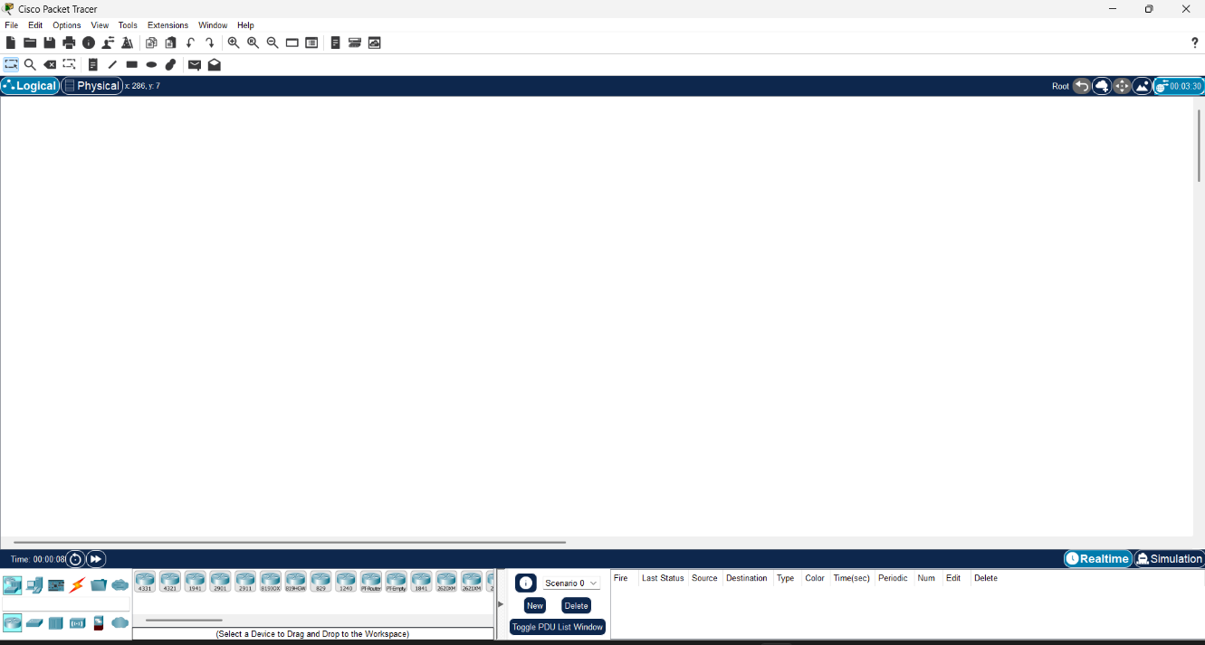
Figure 2.1: Opening the Software

- Adding Devices:
After opening, we will drag and drop one switch (Switch0) and four PCs onto the workspace.
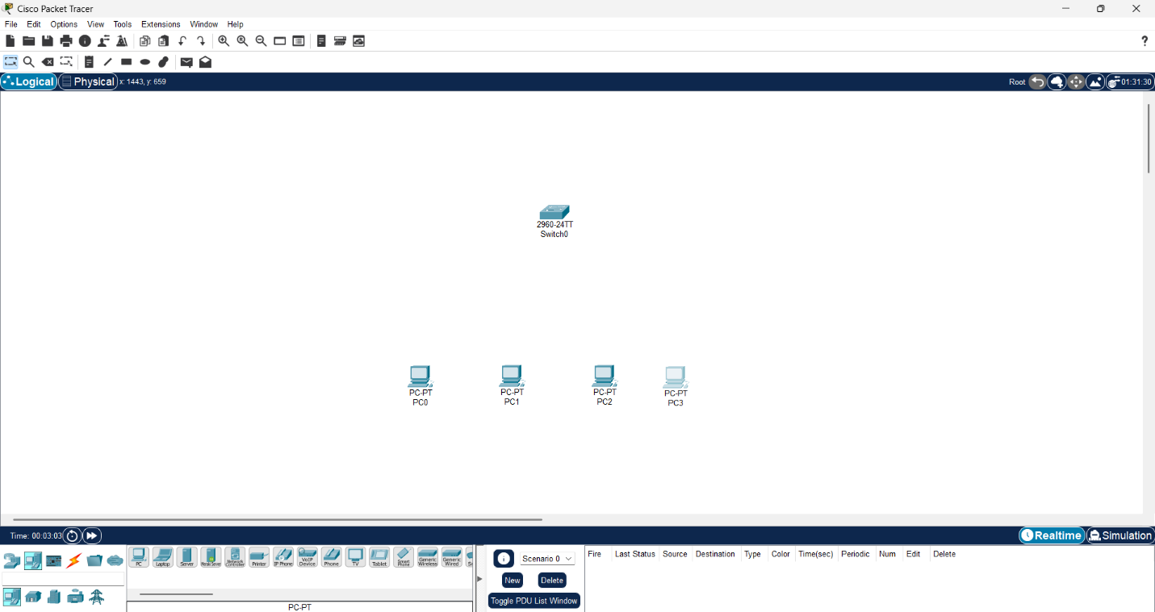
Figure 2.2: Adding Devices

- Connecting Devices:
Using Copper Straight-Through Cables to connect each PC to the switch.
  - PC0 → Switch0 (FastEthernet0/1)
  - PC1 → Switch0 (FastEthernet0/2)
  - PC2 → Switch0 (FastEthernet0/3)
  - PC3 → Switch0 (FastEthernet0/4)

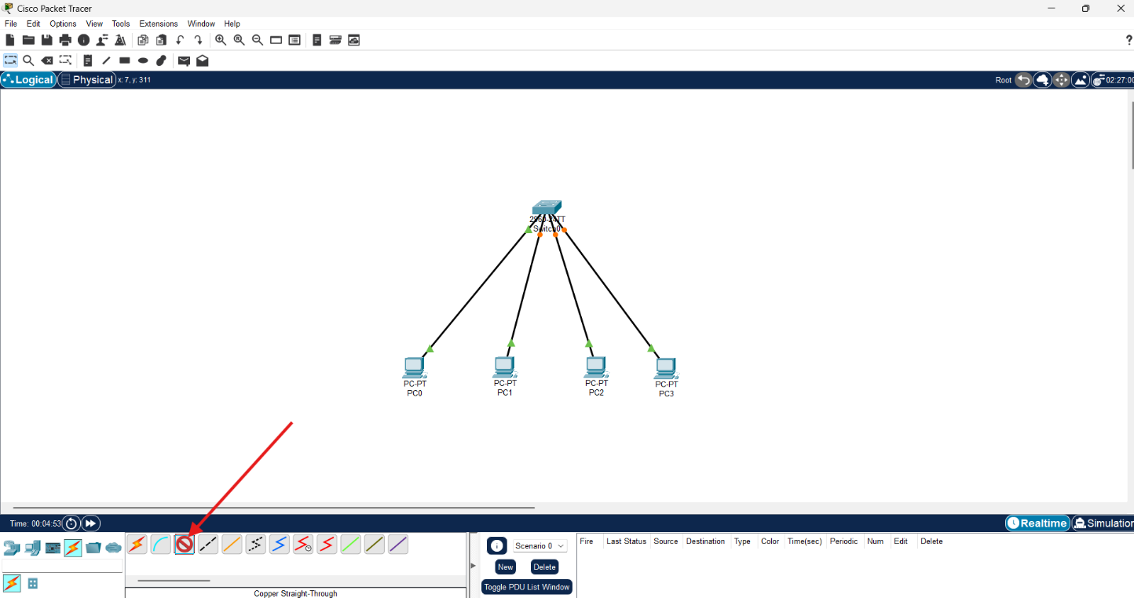
Figure 2.3: Connecting Devices

  - Assigning IP Addresses: In order to assign IP Address to each device, we will go to the device setting by double clicking each device, then from config section we have to go to IP Configuration option. Later we will assign an IP Address to each of the devices.
  - PC0: 192.168.1.1 / 255.255.255.0
  - PC1: 192.168.1.2 / 255.255.255.0
  - PC2: 192.168.1.3 / 255.255.255.0
  - PC3: 192.168.1.4 / 255.255.255.0
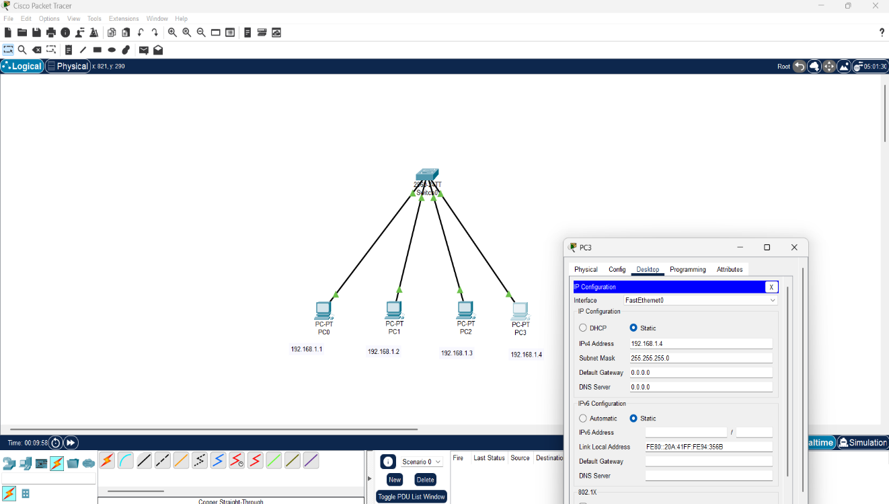
Figure 2.4: Assigning IP Addresses

- Testing Connectivity:
Test The Connectivity By sliding the ICMP packets in each PC and then running the simulation. Here is the figure of the Successful Network setup.
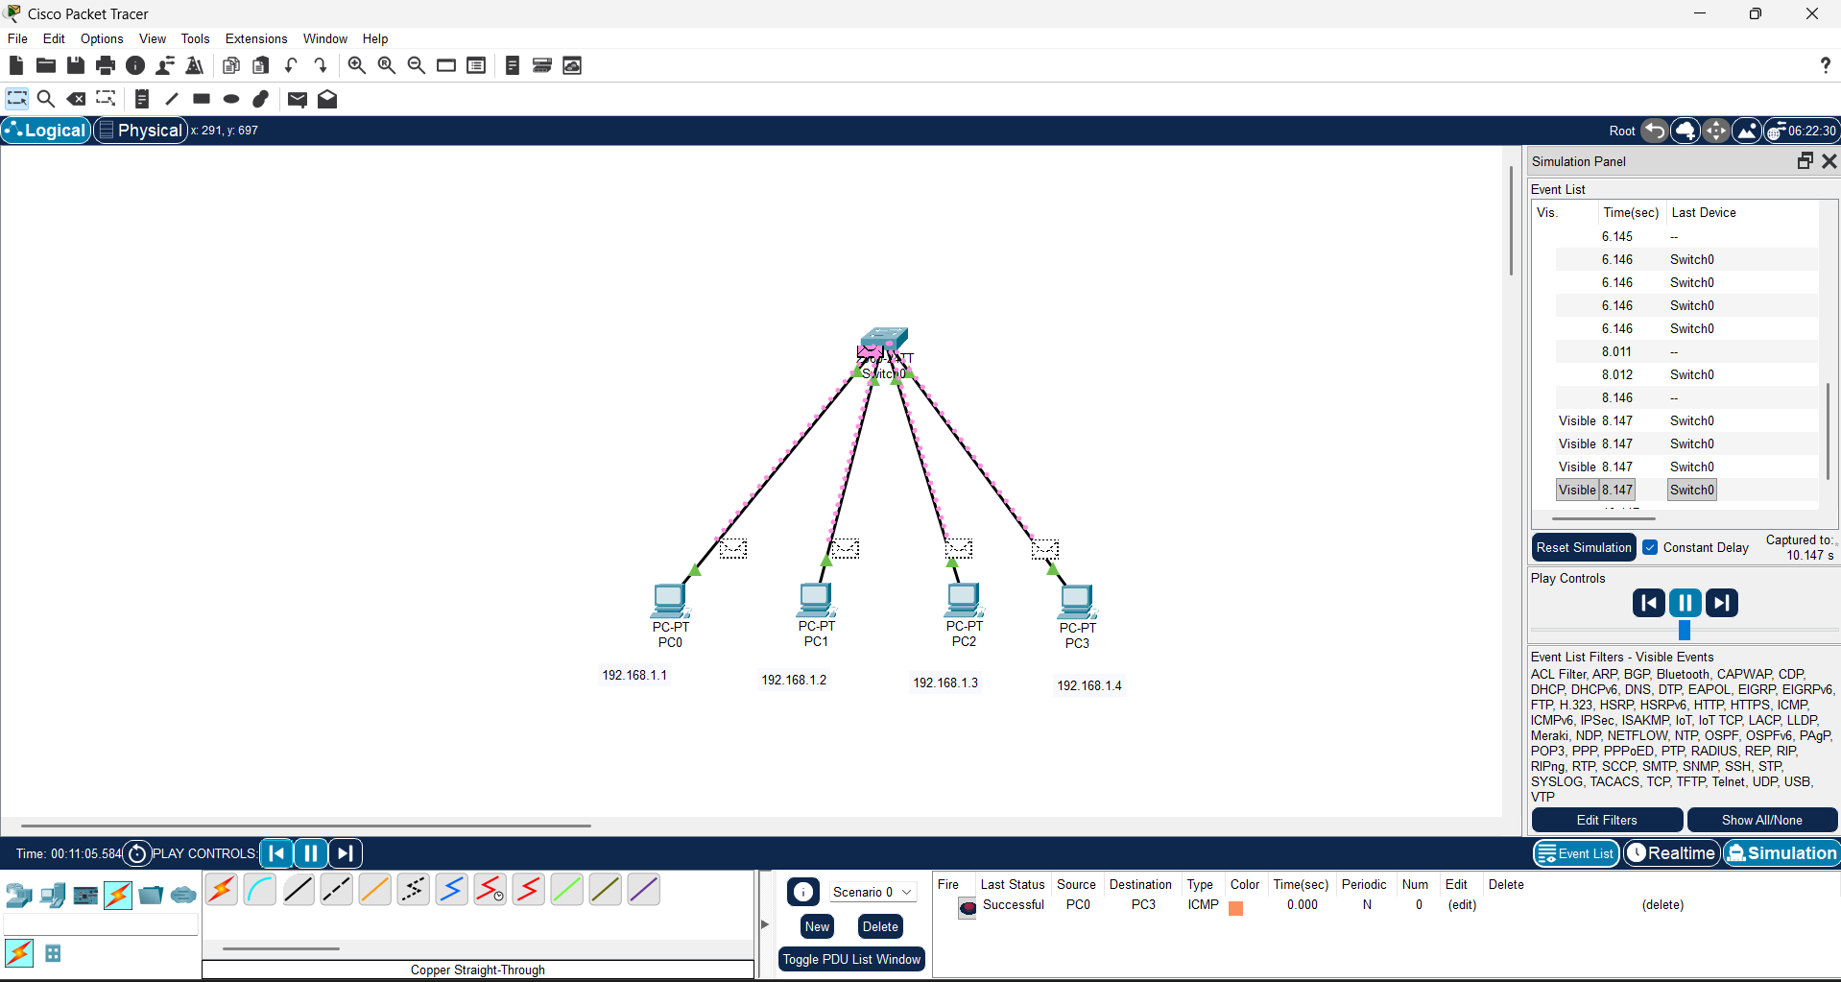
Figure 2.5: Testing Connectivity

Result
All PCs were able to communicate successfully with each other through the switch. The switch efficiently created a local area network (LAN).
Conclusion
This part of the Experiment demonstrated how to design and configure a simple LAN using a switch. The experiment verified the role of a switch in connecting multiple devices within the same network.

